LAB 6 TASK
ROLL NO:24K-0954
TASK 1
INCLUDE Irvine32.inc
.data

msg1 BYTE "Wellcome",0
msg2 BYTE "You Should Not See This Line",0
msg3 BYTE "Good Bye",0
.code
main PROC

; Print first message
mov edx, OFFSET msg1
call WriteString
call Crlf

; Unconditional jump to skip printing msg2

jmp SkipSecondMessage

; This part will be skipped
mov edx, OFFSET msg2
call WriteString
call Crlf
SkipSecondMessage:

mov edx, OFFSET msg3
call WriteString
call Crlf

exit
main ENDP
END main
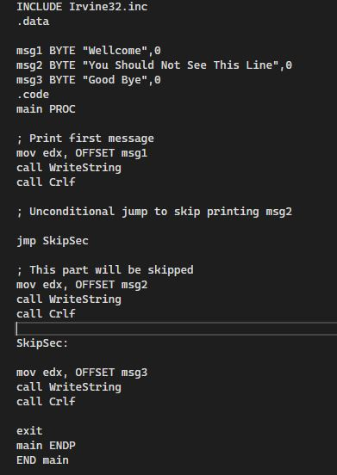
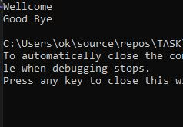

TASK 2
INCLUDE Irvine32.inc
.data
count DWORD 11 ; how many numbers
.code
main PROC
mov ecx, count ; set loop counter
mov eax, 5 ; starting number
L1:
call WriteInt ; print value of eax
call Crlf
inc eax ; increment number
loop L1 ; decrement ECX and jump if not zero
exit
main ENDP
END main
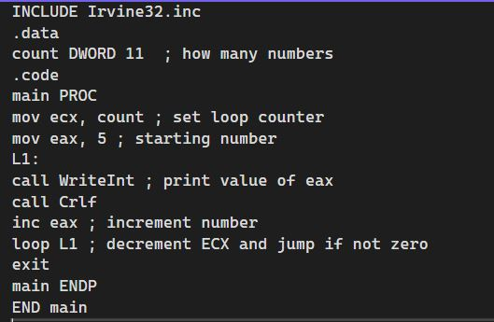
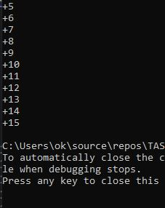
TASK 3
INCLUDE Irvine32.inc

.data
star BYTE "*",0

.code
main PROC
mov ecx, 5 ; number of rows
mov esi, 1 ; stars in current row

outerLoop:
mov ebx, esi ; inner loop counter = stars to print

innerLoop:
mov edx, OFFSET star
call WriteString
dec ebx
jnz innerLoop ; keep printing until row complete

call Crlf
inc esi
loop outerLoop

exit
main ENDP
END main
